PERSONAL INFORMATION | Baligi Cornel
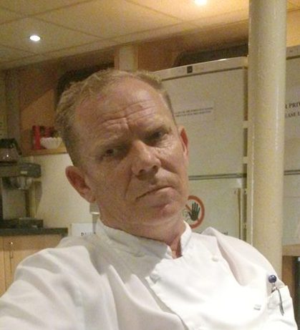 |   Medgidia city, Constanta county, Building P3, ap. 4, Romania

0040764614829

cornel.baligi@yahoo.com
 | Sex Male Date of birth 28/12/1967 Nationality Romanian
SOUS CHEF HOTEL SEIBLISHOF ISCHGL TIROL NOVEMBER 2017 –MAY 2018
JOB APPLIED FOR  POSITION  PREFERRED JOB  STUDIES APPLIED FOR | Sous chef  Breeze River Cruises march 2017-november 2017

WORK EXPERIENCE
2011-2017
Replace with dates (from - to) | Sous chef
Replace with dates (from - to) | River advice  https://www.fleetpro-psm.com/  2009-2011  Sous chef  Viking company  2006-2009  Chef de Partie  River Company  1998-2006  Chef  Luxor Hotel  1990-1996  Chef  La Scoica Restaurant

EDUCATION AND TRAINING
Economic High school Constanta
PERSONAL SKILLS

Mother tongue(s) | Romanian
Other language(s) | UNDERSTANDING |  | SPEAKING |  | WRITING
Other language(s) | Listening | Reading | Spoken interaction | Spoken production
English | Very good | Very good | Very good | Very good | Very good
German | Good | Good | Good | Good | Beginner

Communication skills | - good communication skills gained through my experience as chef, working in a team with more than 9 members in the kitchen  - I had a good communication with all the departments working on the boat or hotel.

Computer skills | Microsoft Office

Driving licence | - no

